ANNUAL DEGREE PROGRAM ASSESSMENT REPORT

Overview
The emphasis of the report should be on PLO and CASLO assessment, action items emerging from those assessments, and a table listing the top three budget requests from each degree program. Bullet points are certainly acceptable for the sections requiring written responses. Refer to the ARPD Instructions when you upload your report elements to the system website. The roman numerals indicate the corresponding system item number for when you upload your report to the UH System website.
http://www.hawaii.edu/offices/cc/arpd/instructional.php?year=2015&action=quantitativeindicators&college=HAW
Select Maui College and your program in the drop down menus.
On the page that shows the Quantitative indicators, click on “web submission”. You will log in to get to your program submission pages.

Remember to click on “save” icon for EACH SECTION.

See the end of this document for more assistance with web submission.

2015-16 Program Review preparation guidelines

Program Name: Automotive Technology
ANALYSIS TAB
I. Quantitative Indicators
Discussion Not Required.
II. Analysis of the Program
- Any new significant program actions (new certificates, stopout, gain or loss of positions) as results of last year’s action plan.
  - Demand Indicators: The data for replacement positions (14) is incorrect. There is a larger demand in Maui County. Employers are requesting employees (students) from our program instead of advertising for them. Our program has a good reputation of sending well prepared entry level techs to industry.

There is a shortage of Automotive Technicians nationally. This is due to techs retiring, leaving industry because of the lack electrical skills etc. Because of this, the automotive students are highly recruited even though they have not graduated from the program. The Automotive Industry on Maui have been offering jobs to our students and are allowing them to continue school. Genius (Good Year) has just hired 3 students Sears (2), Maui Fix Auto (3), Island Honda (2) and we have students who are already employed in the field who are attending classes. These shops are offering better entry level pay because of this shortage. Student do not see the importance of the degree as long as they can attain certification. This why we have a problem of getting our students to graduate. The students come to take our automotive classes to better their skills for employment.
We should be assessed for students who gain employment that are or have been in our program and for graduates. Because we are a Career Technical Education / Vocational Education (CTE/Voc. Ed) Program our first priority prepare our students for job skills to gain employment. By gaining employment, we have fulfilled our students needs and goals.
The program is continuing trying to keep up with industry demands as the industry changes. But because the outdated infrastructure we are just able to provide minimum industry skills. The Automotive Program needs a larger shops and class rooms, another full time instructor, so that we can provide added classes needed to better prepare our students. Our students have to attend day classes as well as night classes. At times they are here 8 hours and some 12 hours at a time. I have noticed in the night classes their performance is poor and they do not have the time to do their take home assignments. Most students who drop an automotive class are night classes. These are the classes that effect our Program Assessment.

- If relevant, share a brief analysis for any Perkins Core Indicator not met.
Significant Program actions: We have received some new equipment and are in the process of acquiring more from System funds. The Automotive Welding class has increased its credits from 2 to 3 credits. The students now meet 2 days a week instead of 1 day in the past. They prefer have more time to improve their skills at welding and feel they can complete the welding requirements in one semester instead of 2 semesters
III. Action Plan

Action Plan
The program is changing Program Learning Outcomes (PLO’s)
PLO
Upon Successful completion of the AMT program the student should be able to:

- Diagnose, Service, and Repair all automotive component systems. These systems include: Engines, Brakes, Fuels/Emissions, Powertrains, Electrical, Air Conditioning/Heating and Ignition Systems.
- To be able to communicate (verbally and written) to customers, management, vendors and other technicians.
- To be able to retrieve information from multiple sources for repairs and estimates.
- To be able to prepare a job application and skills to include creation of a resume and job interview techniques.

Program improvement
IV. Resource Implications:
The campus budget process aligns with the State of Hawaii biennium budget timeline. The next UHMC budget process will be initiated at the beginning of fall semester 2017 for the next biennium. Mid-biennium requests should address a critical need submitted through your department chair.
Budget request
.
1) A new larger facility
$40,000,000?

Our facility is too small and obsolete. Because of this our program cannot meet the latest needs for industry. Because of only a single classroom and such a small lab area our students cannot perform to the best of their ability.
With multi- classrooms and larger lab space we could have classes at a more practical time for the students. Be able to implement new classes to meet industry needs. Provide a safer lab area for our student to work in and be able to work with industry to have training at our facility to meet the community needs.

2) Up to date equipment $80,000

Our industry constantly has changes. This means that in order to meet industry standards we must keep up with the latest equipment. We need this support so that we can teach the latest in industries practice to best prepare our student for employment

DESCRIPTION TAB
Provide a brief description of your program and program mission:

P-SLOs TAB
- PLO selected for assessment (click on the PLO assessed – it will turn green).

  - Industry Validation (check all that apply):

Advisory Committee Meeting(s) _X_, How many? _2_
Did Advisory Committee discuss CASLO/PLO? Yes X__ No__
Coop Ed Placements _X_ Fund raising activities/events __ Service Learning __
Provide program services that support campus and/or community
Outreach to public schools _X_
Partner with other colleges, states and/or countries _X_ PCC
Partner with businesses and organizations _X_
Other__ Describe_______________________________________________________________

  - Expected level of Achievement:
For the PLO assessed, _80_ % of students completing the assignment/course expected to meet expectations for the assignment/course.
  - Courses (or assignments) Assessed:

  - Assessment strategy/Instrument/Evidence (check all that apply):
Work Sample_x_ Portfolio_x_ Project __ Exam _x_ Writing Sample __
Other_x_ Please explain___Lab work base on Mitchell On Demand

  - Results of program assessment:
    - The following were present at the PLO assessment:
    - Strengths and weaknesses (best practices and educational gaps) found from PLO assessment analysis .

  - Other comments:
Describe CASLO assessment findings and resulting action plans. Go to Laulima UHMC CASLO Assessment for your program’s “Assessment results” and summarize below.

CASLO assessment findings | Action plan to address findings
75% students have met minimum to exceptional in achieving the use of Critical Thinking skills. | Keep the courses the same. The students that did not achieve this skill were not serious about the classes , not prepared for college, had personal or family problems.

  - Next steps:
For program learning outcomes (check all that apply):
Assess the next PLO___ Review PLOs_x__ Adjust assignment used for PLO___
Adjust course used for PLO___ Meet with Advisory Committee_x___
Other_x__ Please explain: Revised PLO’s

System website:
http://www.hawaii.edu/offices/cc/arpd/instructional.php?year=2015&action=quantitativeindicators&college=HAW
Select Maui College and your program in the drop down menus.
On the page that shows the Quantitative indicators, click on “web submission”.
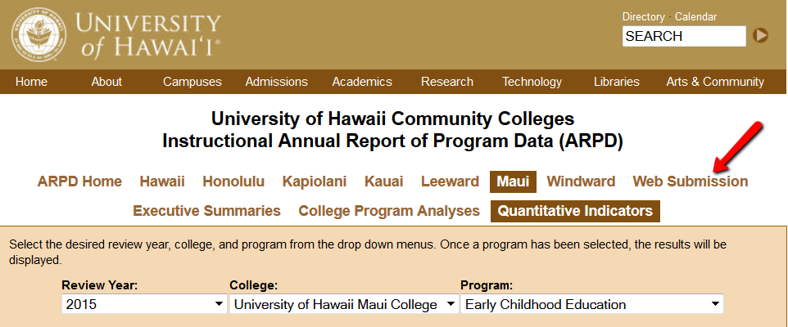

You’ll log in on the next page.
When the page with tabs comes up, click on Analysis tab.
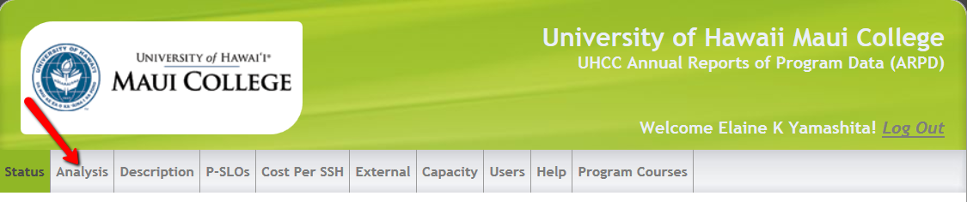

Click on “edit”. Copy and paste from this document into each section. If you are pasting from Word, you need to click on the “W” icon and then paste into the box that pops up (like in Laulima). See green arrow below.
REMEMBER TO “SAVE” EACH SECTION! (red arrow in pic below).

You’ll be entering information into:
- Analysis
- Description
- P-SLOs
- External (if your program has an external exam)

REMEMBER TO SAVE (red arrow) EACH SECTION!
